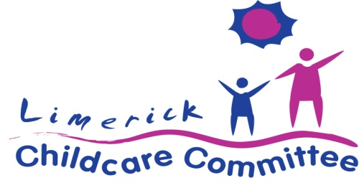

Limerick Childcare Committee is funded through the Department of Children, Equality, Disability, Integration & Youth (DCEDIY) to coordinate the implementation of national childcare policy and programmes at local level.

Job Description for the Position of Childcare Development Officer

Job Title: Childcare Development Officer
Reporting to: Limerick Childcare Committee Manager
Location: Croom Mills, Croom, Co. Limerick

The Purpose of the Job:
- To work as part of the Limerick Childcare Committee team and assist in the implementation of the Local Implementation Plan
- To provide ongoing support, advice and information to early years providers
- To promote quality development in early years services

Outline of Duties and Responsibilities:
- To ensure at all times that the needs and rights of the child are a primary consideration
- To provide support, advice and information to existing and potential childcare services
- To support the DCEDIY and childcare providers with the implementation of childcare funding programmes
- To support childcare providers on governance and sustainability
- To support childcare providers with the identification of childcare needs in their locality, to plan their services, to build capacity, to develop policies and procedures and other relevant/appropriate tasks
- To assist childcare providers to identify training needs to enhance the quality of service provision and to facilitate training courses for childcare service providers
- To facilitate the development of networks of local childcare providers to provide them with information, support and advice
- To support childcare providers in compliance with regulations and funding rules
- To provide information and support to parents, as appropriate
- To assist childcare providers to implement quality-driven practice
- To record all activity on internal database to facilitate tracking of work undertaken
- To assist in the development and maintenance of a current database of all childcare providers
- To plan work, review progress and prepare reports in consultation with the Manager
- To meet deadline as set out by the Manager
- To assist the Manager in implementing the annual work programme under the direction of the Board
- To identify and develop links with relevant local agencies, groups and organisations within the childcare sector in order to facilitate a coordinated approach to the delivery of supports
- To keep abreast of national and local developments in the childcare sector
- To undertake other relevant tasks and duties as they may arise

Person Specification:
The successful candidate must have:
- Minimum of Level 7 qualification in Early Childhood Care and Education or equivalent
- At least 3 years’ practical experience of working in the early childhood care and education sector
- Experience working in a quality support role with childcare services
- Training, facilitation and presentation experience and some experience of working with adult learners
- An in-depth knowledge and understanding of early childhood care and education policy and best practice
- A knowledge and understanding of national early childhood care and education quality and curriculum frameworks
- Excellent interpersonal and organisational skills
- The ability to work in a developmental capacity with groups and individuals in areas of developing committee skills, funding applications, policies & procedures, legal structure, needs assessment, project planning, etc.
- Proficiency in IT and administrative abilities including experience in report writing
- A full and clean driving licence and access to a car
- The ability to work on own initiative and as part of a team

The successful candidate must also be prepared to work flexible hours i.e. evenings and occasional week end time.

Salary scale:
Equivalent to Local Authority Grade 5 (€44,133 - €52,925) depending on experience and qualifications.

Garda Vetting will be required.

The closing date is 4pm, 11th March 2022. Completed Application Forms should be forwarded by post or email marked ‘Childcare Development Officer Post’ to: The Manager, Limerick Childcare Committee, Lower Ground Floor, Croom Mills, Croom, Co. Limerick. anne@limerickchildcare.ie.

Late applications will not be considered.
Applications may be short-listed based on the information given. Interviews will be held during the week of 21st March.
This is a permanent position subject to funding.

Limerick Childcare Committee is an Equal Opportunities Employer, funded by Department of Children, Equality, Disability, Integration and Youth (DCEDIY) through Pobal.

