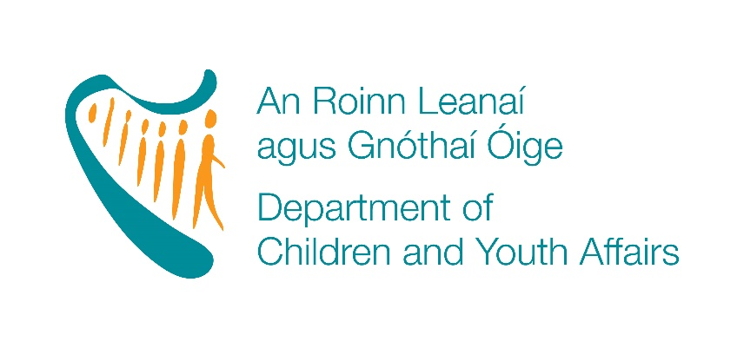

School Aged Childcare Capital
2017
APPLICANT GUIDELINES

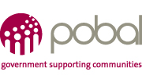

 | Content | Page
1 | Overview of School Aged Childcare Capital 2017 | 3
2 | Selection and award criteria per strand | 4
3 | Important things to know | 6
4 | Additional support for applicants | 8

Overview of School Aged Childcare Capital 2017

1.1 School Aged Childcare Capital 2017
The Department of Children and Youth Affairs aims to increase the number of School Aged Childcare (SAC) places in 2017 and contribute to improving the quality of existing school aged childcare services by providing grants for minor capital works and or equipment.
€3m is available for allocation in 2017 across three strands as follows:
Strand A: Establishment of new SAC services
A grant between €3,000 and €20,000 will be available for the establishment of a new school aged childcare service.

Strand B: Expansion of existing SAC services
A grant between €3,000 and €10,000 will be available for the expansion of existing school aged childcare services. The provision of additional school aged childcare places will be a criterion for this grant.
Strand C: Improvement of existing SAC services
A grant between €2,000 and €5,000 will be available for the improvement of the quality of existing school aged childcare services.

1.2 The Role of Pobal
Pobal has been appointed to administer the School Aged Childcare Capital 2017 on behalf of the Department of Children and Youth Affairs (DCYA).
For more information about Pobal and what we do, please visit our website at www.pobal.ie
The programme will open for applications on Friday 7th April and will close for applications at Friday 5th May 2017 @3pm (15:00hrs).
All queries about the programme should be sent via e-mail to onlinesupport@pobal.ie

Section 2. Selection and award criteria per strand

School Aged Childcare Capital 2017
Overview | There are 3 strands of funding available under School Aged Childcare Capital 2017:  - Strand A: Establishment of new SAC services  - Strand B: Expansion of existing SAC services  - Strand C: Improvement of existing SAC services  Applicants may apply under one strand only.
Programme Requirements | Applications are reviewed by Pobal to ensure that the application meets the basic eligibility requirements. If the application does not comply with these criteria, the application is deemed ineligible.  For all strands:  Applicants must demonstrate that they meet the following criteria:  - Have available a suitable and age appropriate outdoor space for use by the children attending the school age service.  - If expanding or commencing a new service the applicant must have the required planning permission. To demonstrate this a planning reference number is required or a letter from the relevant Local Authority stating clearly that planning permission is not required.  - Completed and submitted the on-line application form by 5th May 2017@ 3pm (15:00hrs).  Eligible applications will be appraised against the following criteria:  - Meeting the grant scheme and strand priorities.  - Value for money.  - Capacity of the organisation.  - Meeting the grant scheme and strand priorities:  Location of proposed/existing service: A suitable location is critical. Applications using schools and existing community facilities will be given priority.  The level of service i.e. the number of hours per day, days per week and weeks per year the service will be made available. Priority will be given to proposals that will offer services during and outside the school term.  Quality and achievability of project proposal. The activities that will be offered and achievability of setting up or expanding or improving services in the timeline outlined will be taken into account.  Additional Strand B priorities  The applicant must outline the number of additional places to be created and their type (part-time or sessional) and whether the service will be available outside of the school term.  The applicant must provide an explanation and supporting evidence to corroborate the current demand or potential demand for additional places over the next 2 to 3 years.  - Value for Money  Under this criterion, the following is taken into account:  - The cost per additional SAC place created (Strands A & B)  - The justification and explanation for the costs detailed within the application form.  - Capacity of the organisation  For school aged services which have a grant agreement with DCYA, Pobal takes account of the following information:  - Any relevant compliance, audit or verification findings.  - Companies Registration Office check on Vision.net.  - Performance against current/previous grant agreements with Pobal/DCYA.  - Issues of concern and or sustainability issues that Pobal or DCYA or the relevant City/County Childcare Committee are currently aware of.  For new SACs, the following information will be taken into account:  - Organisation governance, financial controls, staffing structure and arrangements.  - Track record with other funders and management of business or funding (if applicable).  - Experience in the sector (if applicable).
Who is eligible to apply | Applicants can be either private or community service providers or school boards of management.  Eligible applicants include:  - Existing standalone school age services.  - New standalone school age services.  - Existing school age services who offers SAC as part of their full day care services.  - New early years’ services who now offer SAC as part of full day care services.  - Boards of management of primary schools.
Who is not eligible to apply | - Home based childminders  - Applicants who have an outstanding debt and no repayment agreement with DCYA/Pobal  - Applicants who are currently defaulting on a debt repayment arrangement with DCYA/Pobal
How much can I apply for? | Strand A – the maximum grant an applicant can apply for is €20,000 and the minimum is €3,000.  Strand B – the maximum grant an applicant can apply for is €10,000 and the minimum is €3,000.  Strand C – the maximum grant an applicant can apply for is €5,000 and the minimum is €2,000.
Eligible Costs | This is an indicative list.  - Minor building works  - Painting/decorating  - Age appropriate furniture  - Kitchen equipment, including cookers, fridges, microwaves  - Age appropriate play equipment  - Storage facilities
Ineligible costs | - Non-capital expenditure such as wages/salaries, utilities, consumables etc.  - Office equipment  - Architect fees  - Legal fees  - Any professional fees and planning permission fees associated with the capital works

3. Important things to know

3.1 What is the application process?
This an online application process via the PIP system on the Pobal website (www.pobal.ie)
The call for applications is a competitive application process. Your application will be in direct competition with all other applications received. Only applications that meet the required standard and have submitted all the required documents will be considered for funding.
Applicants who have multiple service facilities can submit more than one application. In the event of that this funding call is oversubscribed the number of applications approved from multiple services may be limited.
No application forms, information or submissions will be accepted via email or in hard copy.
3.2 What you need to do in advance
In preparing the information for your application, we urge you to read this document and view the online tutorial on the PIP portal. We also advise you to:-
- Be as concise as possible in preparing your proposal and in the information included in the application form.
- Obtain permission from the relevant Local Authority to set up a new SAC which is the subject of the application.

Applicants must complete an online application form through the PIP system using their DCYA reference number. If you do not have a valid DCYA reference number, you must contact your local County/City Childcare Committee immediately who will advise you of the application process for obtaining a valid DCYA reference number.

3.3 Completing the online application form
Applications must be made using the online application form, accessed through the PIP portal, using your current User Name and Password. Please refer to our online tutorial.
You will be directed to enter your DCYA reference number, which the system will use to automatically generate your personalised application form. If an application form does not open for you, you may be ineligible to apply and your organisation/service may not meet one or more of the basic requirements. If you believe that you are eligible to apply and the application form is not available to you on the system you can contact us via e-mail to onlinesupport@pobal.ie .
Some information on the application form will be pre-filled from your records on the PIP system. You must contact Pobal if your details have changed, so that they can be amended.
Please be aware that some boxes in the application form have character limits i.e. there is a limit on the amount of text you can insert. The character count includes spaces, punctuation and lines. Please try to be as concise and factual as possible in your responses.
You will be able to edit, save and exit your application form information as often as you like. However, once you submit your online application, the information within the form cannot be edited and no additional documents can be attached or submitted.
The application form must be completed in full. If you have not completed all the mandatory questions, denoted by a red asterisk, you will not be able to successfully submit your application form.

3.4 Key Dates
Online application open | Friday 7th April 2017
Applications close | Friday 5th May 2017 @3pm (15:00hrs)
Appraisal of applications | May 2017
Grant outcomes | June 2017
Grant Agreements issued to successful applicants | June-July 2017
Date by which your grant and own funds must be fully spent and reported to Pobal | 30th November 2017

Please give yourself sufficient time to complete the application form online. Applications received after the closing date Friday 5th May 2017 @3pm (15:00hrs) will be automatically deemed ineligible.
All project proposals must be realistic, achievable and time bound. If successful, applicants must be ready to start their project as soon as they have received an approval email from Pobal. All projects must be completed and the final expenditure report submitted to Pobal by 30th November 2017. No exceptions to this deadline will be made.
3.5 Decision Making
Pobal will appraise all applications and make recommendations to the Department for the Children and Youth Affairs. All Pobal recommendations will be presented to the Minister for approval and final decision.
All decisions will be communicated via e-mail to applicants.
Where an applicant has applied for Early Years Capital 2017, as part of the appraisal process for School Aged Childcare 2017, Pobal will cross reference to ensure there is no duplicate funding awarded.
3.6 Post Approval
- Pobal will issue a grant agreement to all successful applicants, which you will be required to sign and return within the timeframe specified.
- All applicants must be tax compliant prior to the issuing of the grant agreement and a further check will be undertaken by Pobal prior to payment.
- A condition of the funding will be that you must agree to continue to provide SAC services for a minimum of 2 years from the start of the new service or from the date of the last payment, whichever is later.
- All successful applicants are required to comply with public procurement guidelines.
- Where applicants are registered for Value Added Tax (VAT), the grant awarded will be net of VAT.
- Applicants will be required to comply with any statutory standards introduced by Government during the lifetime of the grant agreement.
- All applicants must report to Pobal on the total project costs. All monies must be spent and reported to Pobal before 30th November 2017.

3.7 Payments
All of the grant awarded must be expended and reported to Pobal no later than 30th November 2017.
For applicants who have an existing contract with DCYA/Pobal:
- 90% of the grant will be paid upon receipt of the signed grant agreement and all prepayment conditions (if applicable) have been met in full
- The final 10% of the grant will be paid retrospectively on receipt of the final online financial return detailing how the grant was actually spent. The final payment will only be released when all the correct information has been received with the online return.

For applicants who do not have an existing contract with DCYA/Pobal:
- 50% of the grant will be paid upon receipt of the signed grant agreement and all prepayment conditions (if applicable) have been met in full
- An interim 40% of the grant will be paid retrospectively on receipt of an online financial return detailing how the grant was actually spent and how any specific conditions of funding have been met.
- The final 10% of the grant will be paid retrospectively on receipt of the final online financial return detailing how the grant was actually spent. The final payment will only be released when all the correct information has been received with the online return.

4. Additional support for applicants
Pobal has a help desk, which is available to applicants during the application period. You can contact the help desk in the first instance by e-mail at onlinesupport@pobal.ie or by telephone 01-5117222
Pobal has developed an online support guide for applicants. This can be viewed on the PIP portal.
Applicants may also contact their local City/County Childcare Committee for additional support and advice.

